Group E UVSim Project
Course: CS 2450 – Software Engineering
Instructor: Professor Kevin Burtt
Semester: Fall 2025
Team Members
Ryan Lindsay
Hayden Christenson
Luis Vilchez
Danielle Paje

UVSim – CS2450 Project
This project was created for CS 2450 to simulate how a basic computer processes machine instruction.
UVSim is a small program that acts like a simple computer. It now supports 250 memory slots (000–249), an accumulator for math, and runs instructions written in a language called BasicML.
Programs can use either 4-digit or 6-digit signed numbers depending on the file format.
- 4-digit programs use 2-digit opcodes and 2-digit addresses
- 6-digit programs use 3-digit opcodes and 3-digit memory addresses.
The program starts running at memory address 000 and stops when it reaches a HALT instruction.
This version also includes a graphical user interface (GUI) built with Tkinter, which makes it easy to open files, edit instructions, run programs, and view output directly on the screen.
What’s New in Milestone 5
- Memory expanded from 100 → 250 lines (addresses 000–249)
- Valid addresses now range from 000–249
- Support for new 6‑digit words
  - 3‑digit opcode + 3‑digit operand format
    - Example: 010007 (READ address 007)
Old Files Still Work
- UVSim automatically detects:
  - 4‑digit format
  - 6‑digit format
- Mixed formats in the same file are not allowed
4-Digit → 6-Digit Conversion
- A one-way conversion tool is provided.
Conversion Rules:
- If the first two digits form a valid opcode → instruction
  - Example: 1007 → 010007
- Otherwise treat as a raw number
  - Example: 5555 → 005555

Arithmetic Updates

4-digit files use range ±9999

6-digit files use range ±999999
- UVSim still keeps the last digits if overflow happens (like a real machine)
Better Error Handling
UVSim now checks for:
- Invalid or mixed file formats
- Numbers that are too large
- Memory addresses outside 000–249
- Files with more than 250 lines
- Division by zero
- Invalid opcodes

What You Need
- Python 3.10 or newer
- Tkinter (comes with most Python installs)
- BasicML text files (like Test1.txt or Test2.txt)

How to Install and Run
Make sure you have Python 3.10 or newer installed
Run the GUI
- python3 main.py

Run a BasicML program in the terminal
- python3 main.py Test1.txt

Recommendation folder structure
- main.py
- gui.py
- uvsim.py
- config.json
- tests/
- Test1.txt
- Test2.txt
- InvalidFileTest.txt
- Invalid0pcode.txt

Key Features
- Supports 250 lines of memory (000–249)
- Supports 4-digit or 6-digit BasicML formats
- Automatic format detection
- Built-in 4-digit → 6-digit conversion tool
- Input, output, load/store, arithmetic, and branching instructions
- Full Tkinter GUI with editable instruction window
- Custom color themes saved to config.json
- Strong error handling for invalid opcodes, file formats, and input
- Compatible with all provided test files (Test1, Test2, etc.)
- Includes unit tests for arithmetic, branching, load/store, and I/O

How the GUI Works
The UVSim window is simple and easy to use.
Menu | Function
File → Open | Opens a .txt BasicML file from any folder. The file’s contents appear in the large center text box (instruction editor).
File → Save / Save As | Saves your current program. “Save As” lets you choose a new name or location.
File → Close | Exits the program safely.
Settings → Change Color Scheme | Opens the color picker so you can choose a primary and off color for the app. Your colors are saved to config.json.
Settings → Reset to Default Colors | Resets the interface to UVU’s green (#4C721D) and white (#FFFFFF) color scheme.
Instruction Editor (Center Box) | The main text area where all BasicML instructions are shown. You can type new lines, edit commands, or delete lines here.
Output Panel (Right Side) | Displays messages, errors, and program output during and after execution.
Input Box (Bottom) | Used when a program asks for input (READ command). Type a number and press Enter or click Enter Button..
Run Button | Runs the program loaded in the Instruction Editor. Shows results in the Output Panel.
Reset Button | Clears both the Instruction Editor and Output Panel so you can start fresh.
Enter Button | Sends your input value to the program. Works the same as pressing the Enter key.

Output Box:
The Output Panel shows all printed results from WRITE commands. It also displays error messages and any status updates while the program is running.
If your test files are in a different folder, you can either move them next to main.py or open them manually using File → Open.

Output Panel (Right Side)
- Shows the results of WRITE commands
- Shows errors and status messages

Input Box (Bottom)
- Appears when a READ command needs your input
- Type a number and press Enter or the Enter button

Run / Reset / Enter Buttons
- Run: loads and runs your program
- Reset: clears the editor and output boxes
- Enter: sends your input to the running program

How to Run UVSim
- Open your terminal and run:
- python3 main.py

- The GUI window will open.
- Click Open File and pick a BasicML text file (like Test1.txt).
- Your program will appear in the Instruction Editor.
- Click Run to start executing the program.
- If the program uses a READ instruction, type your number in the input box and press Enter or click the Enter Button.
- You will see the program’s output on the right side in the Output Panel.
- Click Reset to clear the editor and output so you can start over.
- Click File → Close when you are done to safely exit the program.
BasicML Commands
Each instruction takes one line in the text file and is read from top to bottom.
Code | Command | What it does
10xx / 010xxx | READ | Ask the user for a number and save it in memory[xx]
11xx / 011xxx | WRITE | Print value from memory[xx]
20xx / 020xxx | LOAD | Load memory[xx] into the accumulator
21xx / 021xxx | STORE | Save the accumulator into memory[xx]
30xx / 030xxx | ADD | Add memory[xx] to the  accumulator (truncated if too big)
31xx / 031xxx | SUBTRACT | Subtract memory[xx] from the accumulator (truncated if too big)
32xx / 032xxx | DIVIDE | Divide accumulator by  memory[xx] (error if divisor = 0)
33xx / 033xx | MULTIPLY | Multiply accumulator by  memory[xx] (truncated if too big)
40xx / 040xxx | BRANCH | Jump to memory[xx]
41xx / 041xxx | BRANCHNEG | Jump to memory[xx] if accumulator < 0
42xx / 042xxx | BRANCHZERO | Jump to memory[xx] if  accumulator == 0
43xx / 043xxx | HALT | Stop the program
Works for both 4-digit and 6-digit formats.

Supported Formats
UVSim supports 4-digits and 6-digits BasicML formats.
4-digit example
1007 READ to address 07
2109 STORE accumulator into address 09

6-digit example
010007 READ to address 007
021009 STORE accumulator into address 009

4-digit → 6-digit Conversion Rules
- If first two digits are opcode → becomes 3-digit opcode + 3-digit address
- If not an opcode → treat as numeric value

Error Handling
UVSim includes error handling so it doesn’t crash when something goes wrong.
Error Type | What Happens
Malformed File | UVSim shows an error message
Mixed Format | File is rejected
Address > 249 | UVSim stops execution
Too Many Lines | File cannot be loaded
Division by Zero | UVSim stops safely
Overflow | UVSim keeps the last digits
Invalid Input | UVSim asks again

Example Programs
Test1.txt
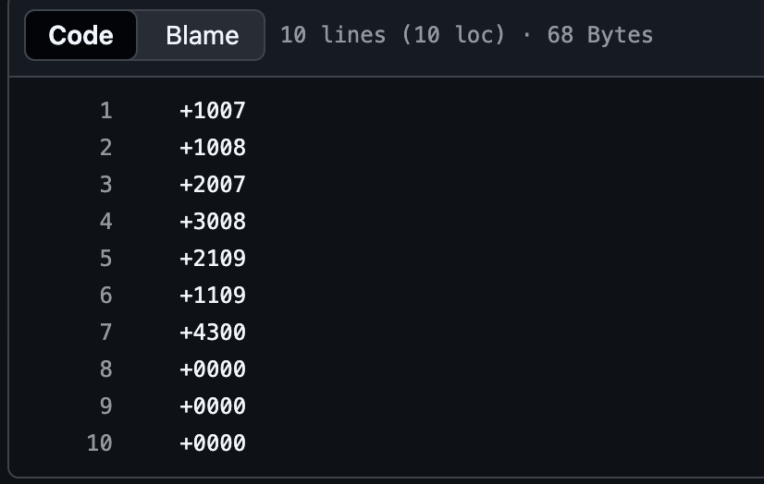
This program asks for two numbers, adds them, and prints the result.

Test2.txt
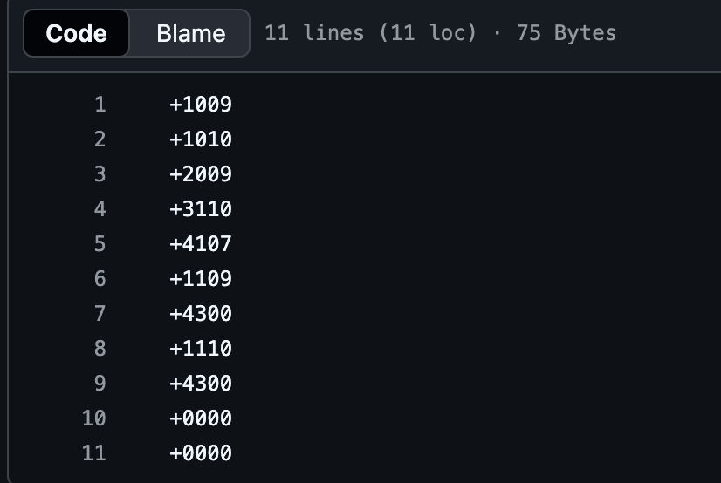
This program asks for two numbers and prints the bigger one.

InvalidFileTest.txt
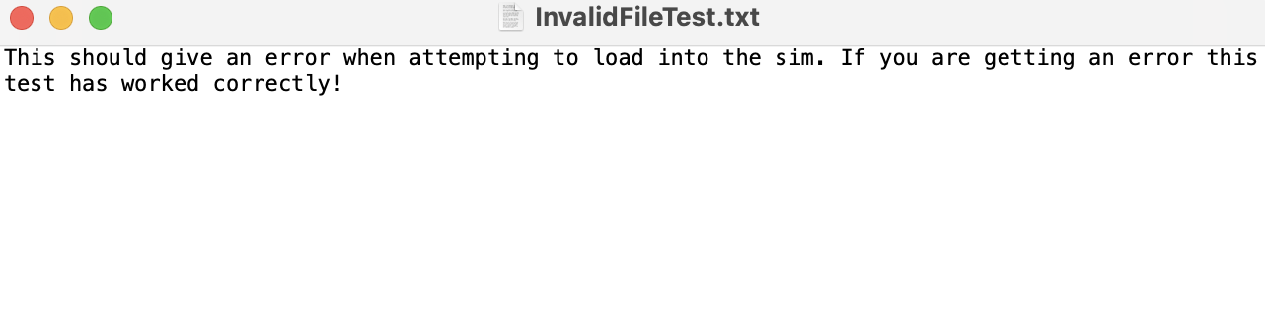Used to test UVSim’s ability to handle broken or incomplete files.

InvalidOpcode.t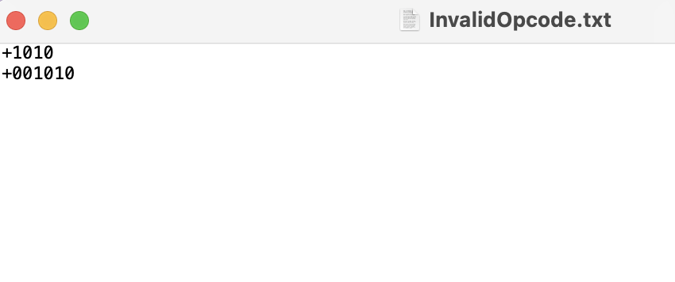
Color Customization
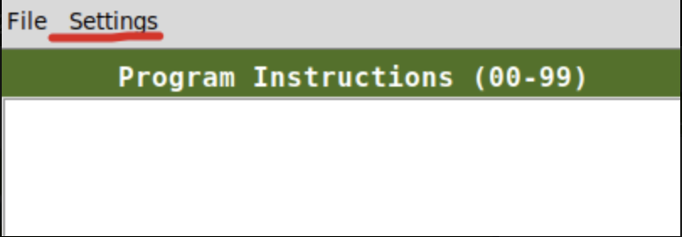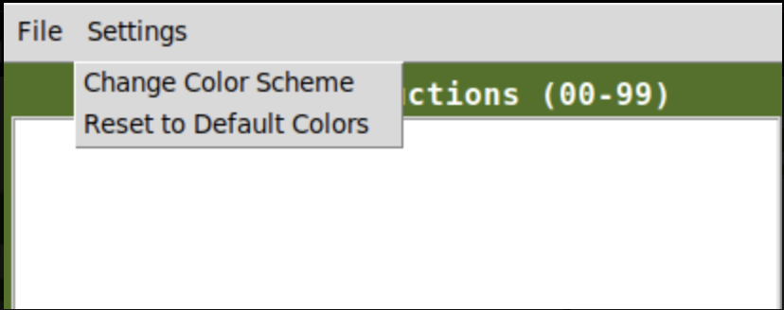
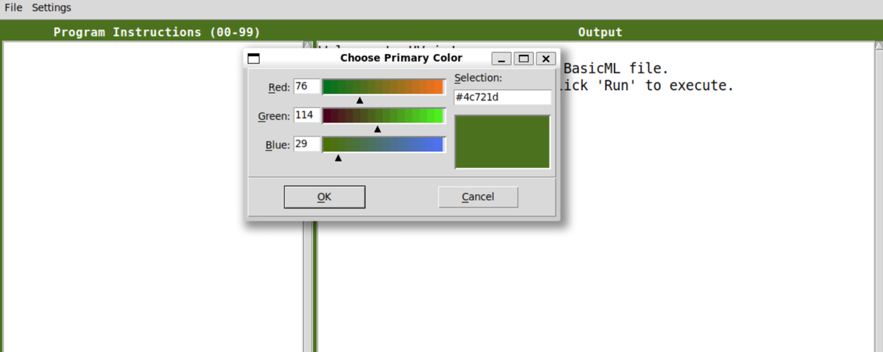

Color Settings
- UVSim allows you to change the colors of the interface.
- You can find these options under Settings in the top menu bar.
  - Settings Menu
    - Change Color Scheme – lets you choose a new primary or off-color
    - Reset to Default Colors – returns UVSim to UVU’s green (#4C721D) and white

Choosing a Color
- When you click Change Color Scheme, a color picker window appears.
- You can adjust:
- Red
- Green
- Blue
- You can also type in a hex value (like #4C721D).
- A preview box shows what the color will look like.
Click OK to apply the color, or Cancel to exit without saving.

How Colors Are Saved
Your chosen colors are saved in a file named config.json.
The next time you open UVSim, it will load your custom colors automatically.

Buttons (Left → Right order)
On the bottom of the window, the buttons appear in this order (left to right):
- Enter
- Reset
- Run

Editing and Saving Files
- You can edit instructions directly in the GUI
- Save and Save As allow exporting anywhere on your computer

Known Limitations
- Only one file can be opened at a time
- Multi‑file tabs planned for future updates
- Some copy/paste operations may be limited

Wireframe 1
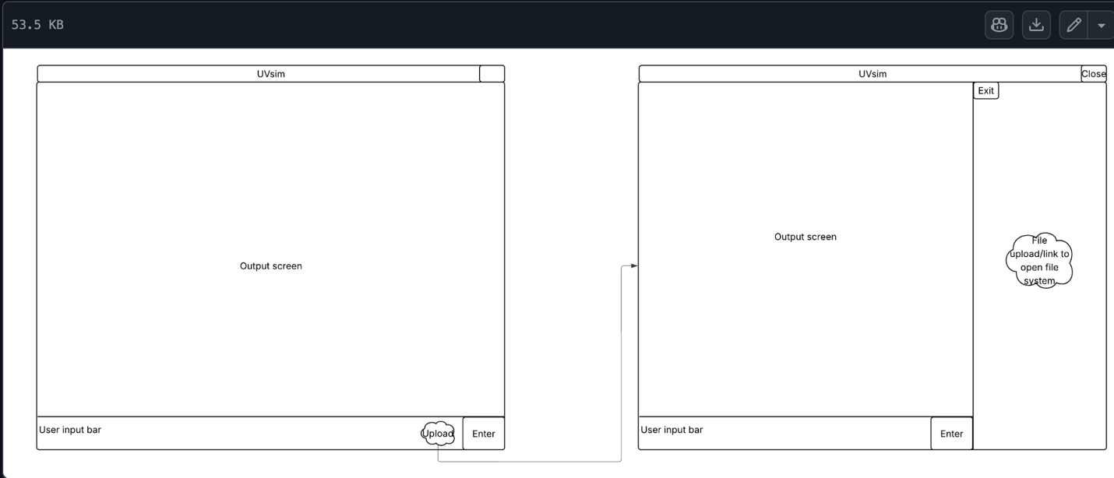

Wireframe 2
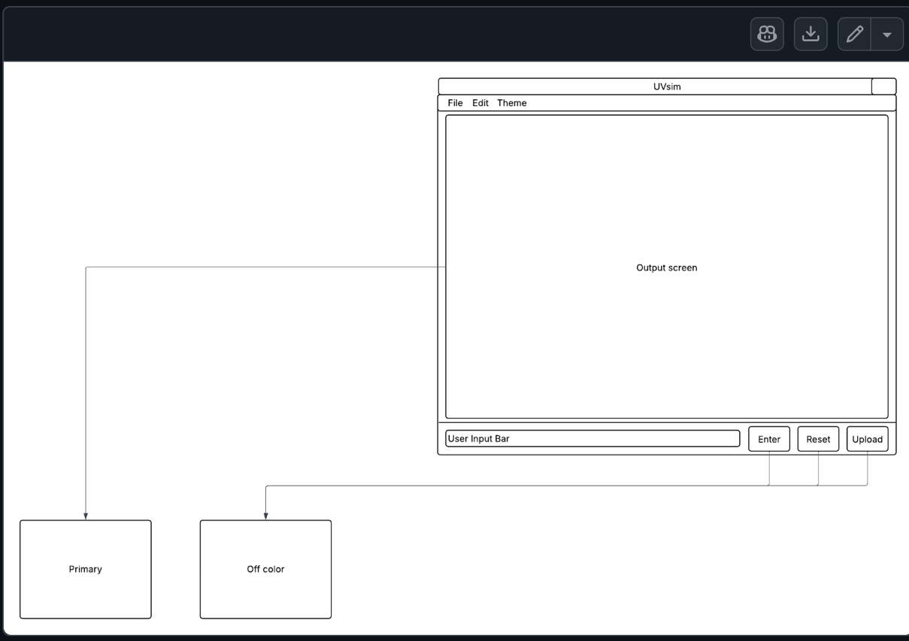
These images show the GUI layout including buttons, menus, and text boxes for user interaction.

Wireframe 3
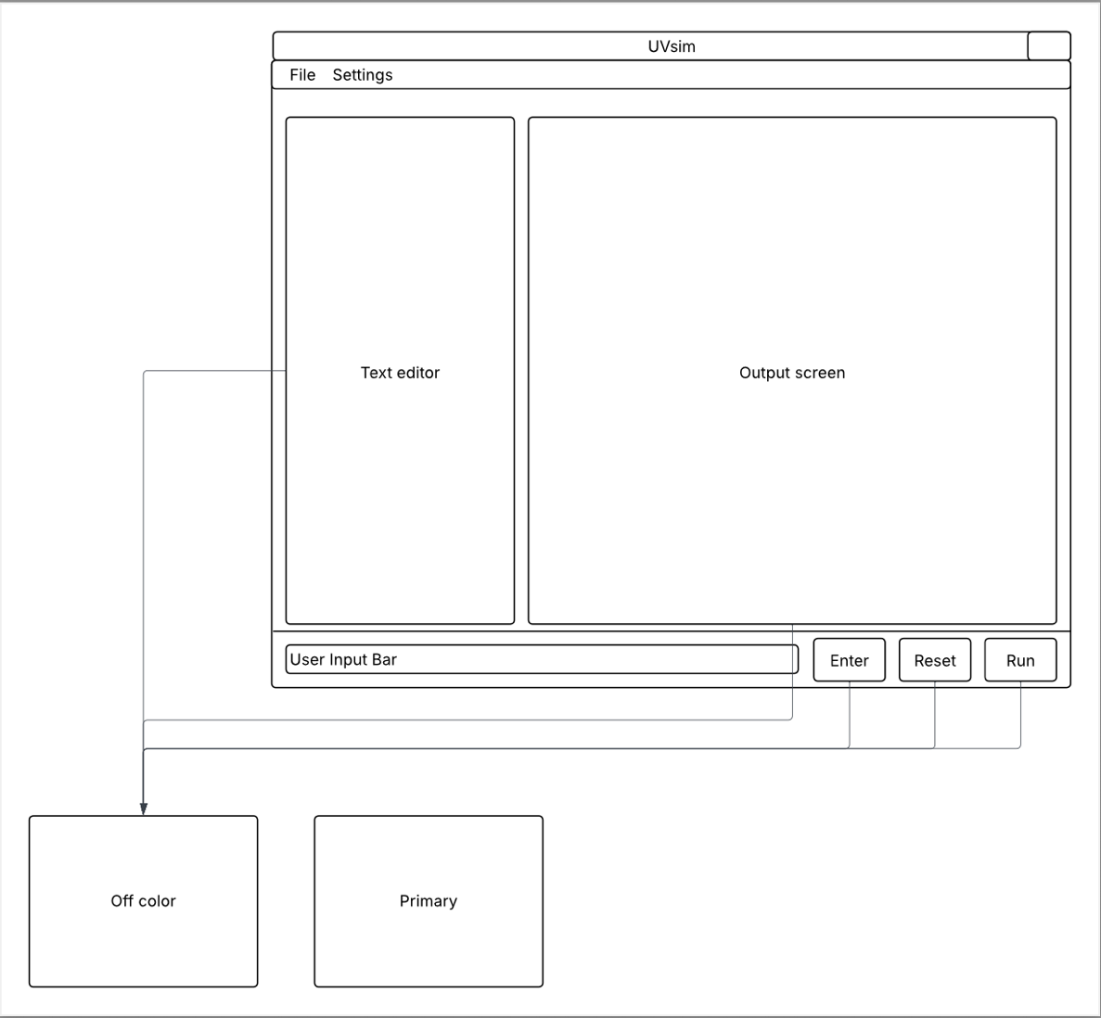

Project Structure
CS2450_Project/
- main.py
- gui.py
- uvsim.py
- tests/
- test_arithmetic.py
- test_control.py
- test_io.py
- test_load_store.py
- Test1.txt
- Test2.txt
- InvalidFileTest.txt
- docs/
- README.pdf
- SRS.docx
- UVSim_Wireframe.pdf
- UVSim Class Document.pdf
- meetings/
- Unit_Tests.csv

Future Improvements
For future development beyond this final milestone, we plan to explore the following:
- Expanded User Experience & UI Enhancements
- Add multi-file support (tabs or sub-windows).
- Show a “format badge” (4-digit / 6-digit) inside each tab.
- Add line numbers to the instruction editor.
- Add dark mode and additional preset color themes.
- Improve layout spacing and resize behavior across screens.

- Advanced Editing Tools
  - Add syntax highlighting for opcodes and numbers.
  - Built-in validation while typing (flag invalid opcodes or addresses).
  - Auto-formatting conversions (pad instructions to 6 digits automatically).
  - Undo/redo history for edits.

- Execution Engine Enhancements
  - Support step-through debugging (Next Instruction, Pause, Continue).
  - Highlight the current executing line in the editor.
  - Add breakpoints for debugging programs.
  - Add performance tracking (execution time, instruction counts).

- Language Extensions
  - Add new BasicML opcodes (e.g., modulus, compare, indirect load/store).
  - Support comments in BasicML programs.
  - Extend memory to allow optional 1000-line mode for advanced users.
  - Add support for named labels instead of numeric addresses.

- Platform & Technology Expansion
  - Create a web-based UVSim version using JavaScript or React.
  - Create a desktop app using PyInstaller or Electron.
  - Add cloud save/load support for programs.
  - Add mobile/tablet-friendly UI mockups for future development.

- File Import/Export Features
  - Add PDF or HTML export for BasicML programs.
  - Add drag-and-drop file loading.
  - Add automatic backup and recovery of unsaved files.

- Education & Training Tools
  - Add guided tutorials that explain how BasicML works.
  - Show tooltips on each opcode explaining what it does.
  - Add a “practice mode” with example exercises.

- Testing & Automation
  - Add automated test runner inside the GUI for student files.
  - Add coverage testing for instruction paths.
  - More robust unit tests for memory handling, 6-digit conversion, and overflow behavior.

- Documentation & Support
  - Expand the user manual with additional screenshots.
  - Add an in-app help menu with FAQ and quick reference.
  - Provide downloadable templates for sample programs.

- Team & Project Management
  - Add contribution guidelines for future team members.
  - Create API documentation for external plugin support.
  - Add a landing page or website hosting UVSim downloads and tutorials.

